Team Name: Smart Solar Siting

End Sprint: 2/25/18

Revision Number: 1

Revision Date: 2/27/18

**Goal**

Our goal for the third sprint is to identify obstructions of sky in an image taken by the app, using the Google Vision API. We also want to connect the app to solar availability data and build the UI. The final task rolling over from sprint 2 is to display the average solar path for each of the months of the upcoming year, not just the current month.

**Task Listing**

1. (5) As a developer, I want to be able to connect the database containing information on solar calculations to my app.
2. Set up the API and test if the calls work (4-5 hours)
3. (5) As a user, I want to be able to switch between a user interface and the real-time camera view
4. Make a UI and have a button that switches back and forth (3-4 hours)
5. Make it look nice (1-2 hours)

1. (21) As a user, I want to be able to identify obstructions that would project shadows at certain angles, such as trees, buildings, etc.
2. Research methods to differentiate between the sky and an object (~10)
3. Start working on implementing methods to differentiate objects in sky(~10)
4. As a user, I want to be able to see the solar paths for every different month on the camera view
   1. Write algorithm to correctly calculate the average solar path per month, taking into account the months which should be the same (3 - 4h)
   2. Show the solar paths as different points on the camera view, with text saying which month is which (2 - 3h)

**Team Roles**

Mattheo - Developer/Scrum master

Andrew - Developer

Nicki - Developer

Chris - Developer/Product Owner

Sam - Developer

**Initial Task Assignment**

Mattheo - 4A, 4B

Andrew - 3A, 3B, 1A

Nicki - 3A, 3B,

Chris - 4A, 4B

Sam - 2A, 2B

**Initial Burnup Chart**

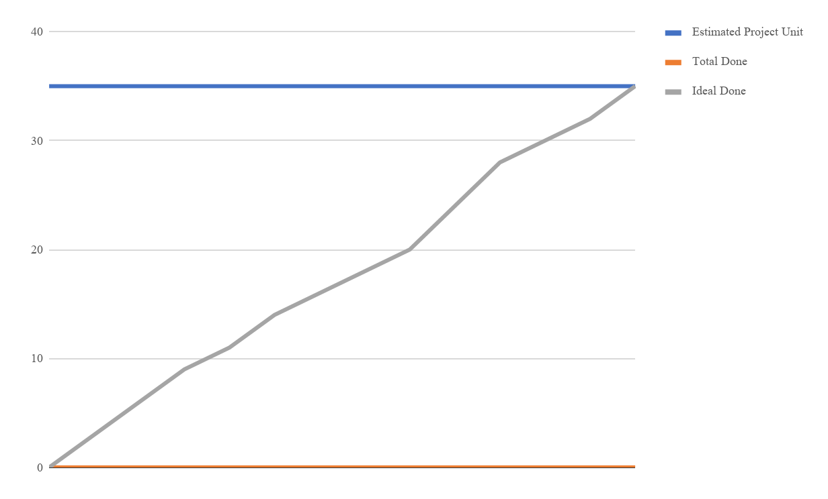

**Total hours - 38**

**Initial Scrum Board**

**Scrum Times**

Tuesday 10:00 - 10:20 - Lecture theatre

Thursday 10:00 - 10:20 - Lecture theatre

Friday 13:00 - 13:20 - Baskin 316